**Project conclusion & user manual**

Looking at this project beeing an audio exercise, we have learned a lot by designing this gadget. The project idea was aimed big, looking at the time available. We could get the audio part working, which became overwhelming, meaning that the focus switched a bit. The distance sensor became a musical instrument, featured with a four state cube compained by a joystick and some buttons and switches for settings filled up with jazz inside, while the MIDI part and capacitive sensing are not handled by now. A connection to the ESP32 µC was priorized for network inclusion.

**Joystick**

The dual axes joystick offers quick changing of root note, osc2 offset and waveshapes. See current configuration table.

**LED switches**

In cube mode 1 oscilllator 1 and 2 can be switched on and off. The current state is indicated by a white LED. We used rugged metal switches to get some quality feel on the prototype. They are ready for an even more professional built version.

**Buttons**

The 3 multi-purpuse momentary buttons are used for settings and tests. The functions vary depending on cube and settings mode. See current configuration table.

**4 state cube**

Detects four orientations of a cube by using two KY-027 Magic Light Cup sensor modules. This helped us a lot for testing new functions since we always had two or three test modes available without touching working routines. The cube can be used musically as a note off command by turning to cube mode 2 or turning the device into a speaker tester by letting it run a frequency sweep in mode 0. The jazz theremin can be found on main mode 1. The modes are indicated as binary on the two module LEDs. See current configuration table.

Cube Modes

1: theremin plays many jazz scales

2: stop sound, play single notes on buttons [note off and test mode]

3: button 1: play notes sweep up | button 2: play frequency sweep down

4: [test mode]

**Distance echo control**

# The HC-SR04 ultrasonic distance sensor module measures the distance to any reflecting solid object sending a 40 kHz trigger and waiting for the echo. The module sends the distance value via a pulse with varying width. On the rising edge of the pulse, a timer gets enabled. The timer value is read and reset on the falling edge interrupt of the echo pulse. The distance controls the pitch in jazz theremin mode. By default the increment is chromatically. If a scale is selected, only notes which are represented by that scale will sound.

**ESP32 UART connector**

Since we wanted to try out the idea of connecting to different µCs we skipped the MIDI part as fast UART responder and priorized a ESP32 connection for handling the display and possible further inputs via ESPNOW and webserver control. Combing stable, lossless MIDI and other fast UART connections while reading an interrupt based distance sensor is not achieved yet.

**I2C OLED display**

The 1.3 inch OLED display is connected to the ESP32 via I2C and makes use of the faster u8x8 library which is part of u8g2 by Oli Kraus (<https://github.com/olikraus/u8g2>). The OLED display is great for showing settings such as root note, scale names etc. but the downside with these I2C modules is always the speed. So we decided to outsource this task to the ESP32 for now. We had an 0.96 inch OLED running on the PsoC by using an adapted SSD1306 OLED driver by Derk Steggewentz (<https://github.com/derkst/Cypress-PSOC-OLED>) but it went slow and did not work well while using distance echo control.

**Current configuration table TODO**

|  |  |
| --- | --- |
| **Cube Mode 0 [test sweeps]** |  |
| Button 1 | chromatic notes up |
| Button 2 | frequency sweep down |
| Button 3 |  |
| Switch 1 |  |
| Switch 2 |  |
| Joystick Switch |  |
| Joystick Up |  |
| Joystick Down |  |
| Joystick Left |  |
| Joystick Right |  |

|  |  |  |
| --- | --- | --- |
| **Cube Mode 1 [jazz theremin]** | **Settings Mode 1** | **Settings Mode 2** |
| Button 1 | note delay cycling up | octaves cycling up |
| Button 2 | scale group cycling up | scale group cycling up |
| Button 3 | scale cycling up | scale cycling up |
| Switch 1 | osc 1 on / off | osc 1 on / off |
| Switch 2 | osc 2 on / off | osc 2 on / off |
| Joystick Switch | toggle settings mode | toggle settings mode |
| Joystick Up | osc 1 root note up | osc 2 offset up |
| Joystick Down | osc 1 root note down | osc 2 offset down |
| Joystick Left |  |  |
| Joystick Right | cycle waveshapes osc 1 | cycle waveshapes osc 1 |

**Schematics TODO**

**Pinouts TODO if changed**

**Psoc Pinout**

The PSoC is powered via USB leaving the KitProg unsnapped for now.



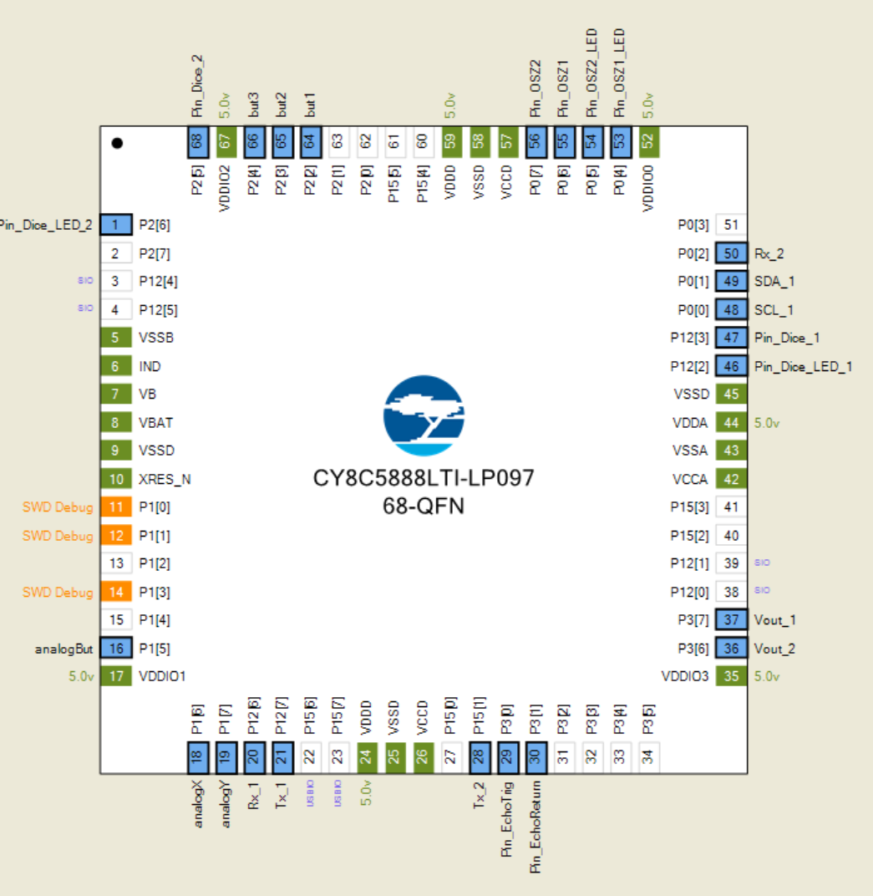

**ESP32 Pinout**

The ESP is powered using the PSoC’s 5V on the VIN pin. For debug and programming purposes it can also be powered via USB.

|  |  |
| --- | --- |
| VIN | Voltage Shifter VB [5V] |
| GND | Common Ground |
| 3V3 | Voltage Shifter VA [3.3V] |
| D19 | Voltage Shifter OE |
| RX2 [16] | Voltage Shifter A1 |
| TX2 [17] | Voltage Shifter A2 |
| D22 | Display SCL |
| D21 | Display SDA |

**Part Info & Datasheets**

# HC-SR04 Ultrasonic Distance Sensor

<https://cdn.sparkfun.com/datasheets/Sensors/Proximity/HCSR04.pdf>

# 1.3 inch OLED I2C 128 x 64 Pixel Display

<https://cdn.shopify.com/s/files/1/1509/1638/files/1_3_Zoll_Display_Datenblatt_AZ-Delivery_Vertriebs_GmbH_rev.pdf?v=1606164520>

# Steel Push Buttons 0.63 inch flat LED Ring White

<https://www.led-taster.de/mediafiles/Sonstiges/Datenblatt/16/P16-RF-X.pdf>

**B3F-1 Tactile Button Switches**

<https://cdn-shop.adafruit.com/datasheets/B3F-1000-Omron.pdf>

# KY-023 Dual Axis Joystick Module

<https://arduinomodules.info/ky-023-joystick-dual-axis-module/>

# 8 Ohm Speaker

<https://components101.com/sites/default/files/component_datasheet/8%20ohm%20speaker.pdf>

**KY-027 Magic Light Cup Module**

<https://arduinomodules.info/ky-027-magic-light-cup-module/>

**TXB0108 Bidirectional Voltage Shifter**

<https://www.adafruit.com/product/395#technical-details>

<https://cdn-shop.adafruit.com/datasheets/txb0108.pdf>